**Report – Web Development**

In my report I’ll be giving a brief reflection on how I found the development of my website, how I applied the coding and design aspect and how I dealt the debugging process of the coding. I will be adding my wireframes below to give an insight to the ideas I had for my initial website.

Due to this project being my first development of a website, I found it hard to get a grip on how to do the HTML coding and CSS Styles. However, as the lessons went on, I managed to grasp the basic concepts of HTML coding.

The first stage of the development of my website was the planning process. This consisted of my wireframes. The wireframes were created to give a vision of how I wanted the webpage to be designed and made it easier to have a plan to follow when it came to start my coding.

Screen shots of the wireframes for the website.

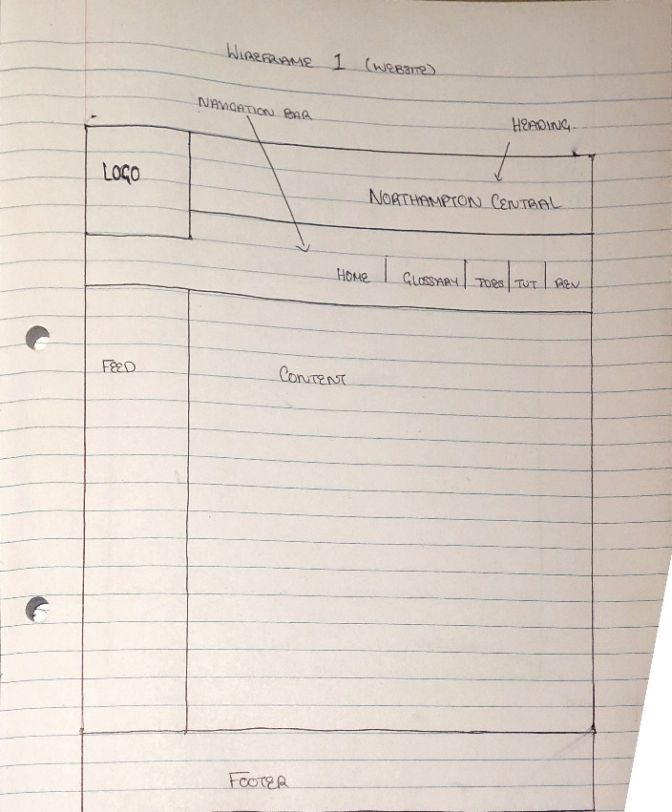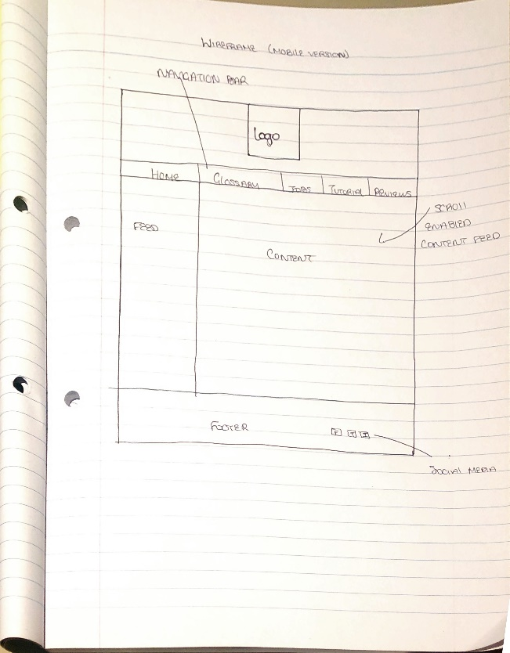The next stage was HTML coding and CSS Styling. I found this portion the hardest as there was a lot to remember, and if a section wasn’t right, the previewed result will not co-operate with what the plan is. There were a few issues I ran into when implementing the code, some of which were the colouring of the background, getting the alignment of the text in the right place and getting the image (logo) in the right place and with the right variating sizes.

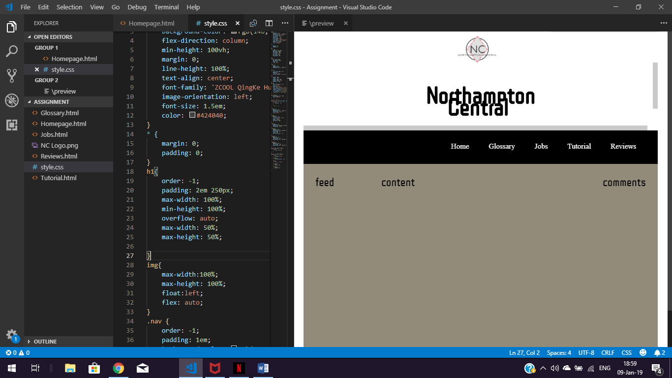

This is a screenshot shows the issue I was having with the colour theme. My original plan was to have the whole page grey and the navigation bar and footer black. I found a way to change the background and where to add the code to make this modification.

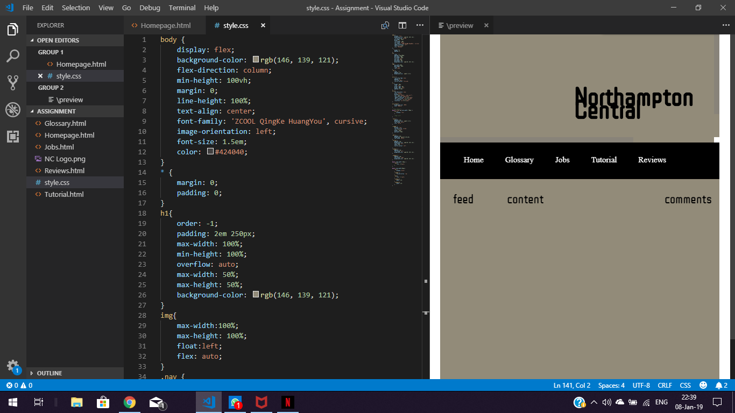

This screenshot was showing the issue with the logo coding and styling. As you can see in the image below, the image is seen in the middle of the page, when it was meant to be at the end, however, now (as the screen got smaller) the logo is no longer visible and not in the top left-hand corner.

In conclusion to this report, I have found the development of the website challenging but as I kept putting into practice the skills, I have managed to slowly put together a basic news website called Northampton Central.

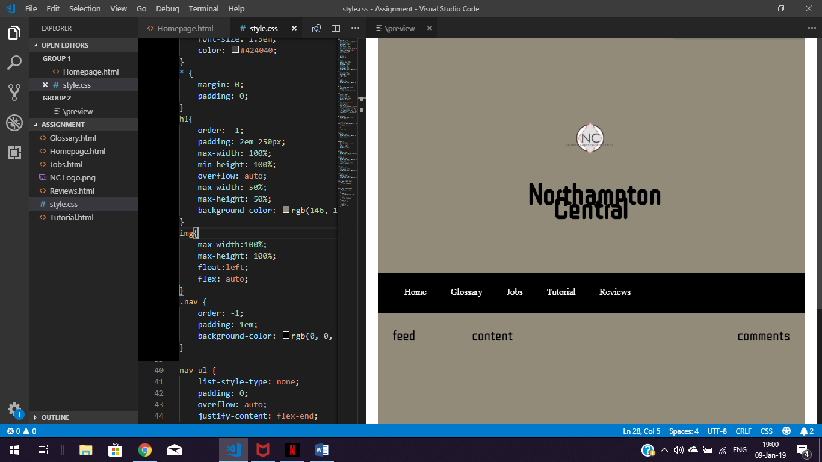  
This screenshot is showing the issue of the alignment of text. The text was too close together and one above another, when it was meant to be side by side. This issue is still on the mend